Objectives

* Inheritance

**There are 7 Challenge Exercises, each worth 14.2%**

**Inheritance** allows a new class to extend an existing class. The new class inherits the members of the class it extends. Inheritance allows to inheritance of attributes and methods from a parent class to a child class or classes.

**Project #1:** here we have two classes A and B with two functions in each class. Notice, each class only can see each function to which it is assigned, meaning that Class A is only able to see functions one and two, and Class B is only able to see functions three and four.

self represents the instance of the class. By using the “self” we can access the attributes and methods of the class in python. It binds the attributes with the given arguments.

**Program’s output:**

Now, we will inherit from Class A to B, meaning that Class B will inherit from Class A, if you see line #8 where class B(A) is inheriting class A and **lines #25-28** object b1 is able to see the four functions.

**Program’s output:**

Since Class (A) is the superclass or the parent class, Class A cannot inherit from class B. See line #1 Class A(B) so, **lines #19-20** will display an error.

**Project #1 (A):** An object inheriting from two different classes

**Program’s code and output:**

**Challenge Exercise #1:** continuing from project #1 (A), add the 3rd animal and print screen the results with the code below:

**#1 print screen the output with the code below here**

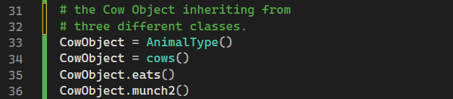

**Project #1 (B):** this example is using the super keyword to inherit attributes and arguments.

__init__ method initializes object attributes so they can be shared throughout the program

**Program’s output:**

Entering information and passing the attributes to parameters. **(Enter lines 13-16 and 30-33)**

**Program’s output:**

**Challenge Exercise #2:** Continuing from project #1 (B) add to the super constructor (see line 23) and add the address, city, state, and zip code) for the Student and Teacher. Print screen below.

**#2 print screen the output with the code below here**

**Project #2** (This is another example of two classes and inheritance, the car_demo class will inherit from the Automobiles class), the __init__ function is called automatically every time the class is used to create an object.

Create a new class and name its **vehicles** and type in the following code below:

Create a second class and label it as **car_demo** this will act as the superclass or the main class that will inherit from the Automobile class

**Program’s code and output:**

**vehicles.py**

**car_demo.py**

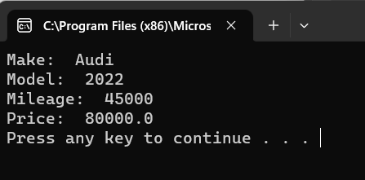

**Challenge Exercise #3:** Continuing from project #2, print out another car’s description. See the example below:

**#3 print screen the output with the code below here (Need code for each class)**

**vehicles.py**

**Challenge Exercise 3.py**

**Challenge Exercise #4:** Continuing from project #2, add the number of doors for each car, be sure to add a mutator and an accessor for the door description.

**#4 print screen the output with the code below here (Need code for each class)**

**vehicles.py**

**Challenge Exercise 4.py**

**Challenge Exercise #5:** See the UML diagram below and create the following three classes. The Insect class will be the main or the superclass and the bumblebee and grasshopper classes will act as the two sub-classes. Provide two characteristic behaviors for the bumblebee and grasshopper, be sure to use Mutator and Accessor methods for each class. Print or display the two characteristics of each insect below.

**#5 print screen the output with the code below here (Need code for each class)**

**Project #3** (This is a continuation of project #2 (Automobile class)

On the Automobile class type in **line numbers 39-46**

Under the main class type in **lines 19-36**

**Program’s code and output:**

**vehicles.py**

**Project 3.py**

**Challenge Exercise #6:** Continuing from project #3, add an electric vehicle car with the same description, and print the screen below.

**#6 print screen the output with the code below here (Need code for each class)**

**vehicles.py**

**Challenge Exercise 6.py**

**Challenge Exercise #7:** complete the following below:

**#7 print screen the output with the code below here (Need code for each class)**

**employee.py**

**Challenge Exercise 7.py**

**Submit this document to the Module 13 class exercise.**